CMSC/CIS 255 Fall 2016
Homework 6 Solution – Database Creation & Querying

- Create the database shown below by writing SQL script(s). The database should be called HW6_YourNameHere.
The Employee table’s PK is EmployeeID, and should be an IDENTITY column.
DepartmentID is the PK in the Department table (it should NOT be an IDENTITY column) and is an FK in the Employee table.
Both tables should be in a schema called Admin.
Hand in the script(s) and a screen-shot of both tables. (25 points)

Employee Table
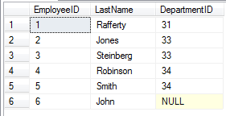

Department Table
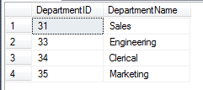

IF DB_ID('HW6_MarkBrodie') IS NULL
CREATE DATABASE HW6_MarkBrodie;
GO

USE HW6_MarkBrodie;

IF SCHEMA_ID('Admin') IS NULL
BEGIN
EXEC ('CREATE SCHEMA Admin AUTHORIZATION dbo')
END
GO

IF OBJECT_ID('Admin.Employee', 'U') IS NOT NULL
DROP TABLE Admin.Employee;

IF OBJECT_ID('Admin.Department', 'U') IS NOT NULL
DROP TABLE Admin.Department;

CREATE TABLE Admin.Department
(
DepartmentID INT NOT NULL,
DepartmentName VARCHAR(20) NOT NULL UNIQUE,
PRIMARY KEY(DepartmentID),
CHECK(DepartmentID > 0)
);

CREATE TABLE Admin.Employee
(
EmployeeID INT NOT NULL IDENTITY,
LastName VARCHAR(20) NOT NULL,
DepartmentID INT NULL,
PRIMARY KEY(EmployeeID),
FOREIGN KEY(DepartmentID) REFERENCES Admin.Department,
CHECK(EmployeeID > 0)
);

GO

INSERT INTO Admin.Department(DepartmentID, DepartmentName) VALUES(31, 'Sales');
INSERT INTO Admin.Department(DepartmentID, DepartmentName) VALUES(33, 'Engineering');
INSERT INTO Admin.Department(DepartmentID, DepartmentName) VALUES(34, 'Clerical');
INSERT INTO Admin.Department(DepartmentID, DepartmentName) VALUES(35, 'Marketing');

INSERT INTO Admin.Employee(LastName, DepartmentID) VALUES('Rafferty', 31);
INSERT INTO Admin.Employee(LastName, DepartmentID) VALUES('Jones', 33);
INSERT INTO Admin.Employee(LastName, DepartmentID) VALUES('Steinberg', 33);
INSERT INTO Admin.Employee(LastName, DepartmentID) VALUES('Robinson', 34);
INSERT INTO Admin.Employee(LastName, DepartmentID) VALUES('Smith', 34);
INSERT INTO Admin.Employee(LastName, DepartmentID) VALUES('John', NULL);

GO

- Perform the following queries on your database. The queries must be written so that they would work even if the amount of data was much larger. Hand in each query and a screen capture of the complete result set. Explicitly validate the results of each query. Remember that you have to decide whether duplicates should be allowed in each result or not.

- Show the ids and names of all students taking a class whose title starts with a letter in the 2nd half of the alphabet. (10 points)
SELECT DISTINCT S.StudentID, S.StudentFirstName, S.StudentLastName
FROM Student as S JOIN Enrollment as E ON S.StudentID = E.StudentID
JOIN Class as C ON E.ClassID = C.ClassID
WHERE C.ClassTitle LIKE '[N-Z]%';

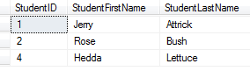
- Show the class-title and student-last-name for all classes where a grade of ‘B’ has been given. The output should be sorted by instructor-id, from smallest to largest. Classes with the same instructor should be ordered alphabetically by class-title.
(10 points)
SELECT C.ClassID, ClassTitle, StudentLastName
FROM Enrollment AS E JOIN Class AS C On C.ClassID = E.ClassID
JOIN Student AS S ON S.StudentID = E.StudentID
WHERE Grade = 'B'
ORDER BY InstructorID, ClassTitle;

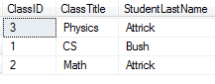
- Show each student’s name and how many courses they are taking, in alphabetical order by last-name. The student’s name should be a single column showing their full-name. Students taking no courses should appear in the output with a zero as their course-count. (10 points)
SELECT S.StudentFirstName + ' ' + S.StudentLastName AS Name,
COUNT(E.ClassID) AS NumberOfClasses
FROM Student AS S LEFT OUTER JOIN Enrollment AS E
ON S.StudentID = E.StudentID
GROUP BY S.StudentLastName, S.StudentFirstName
ORDER BY S.StudentLastName;

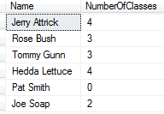

- Show each instructor’s name, together with how many courses and how many students they are teaching, ordered in descending order by number of courses. The instructor’s name should be 2 separate columns, first-name then last-name.
If an instructor teaches the same student in 2 different classes, that student should be counted twice. Instructors teaching the same number of courses should be in descending order by number of students. Instructors teaching no courses should NOT appear in the output. (15 points)
SELECT I.InstructorFirstName, I.InstructorLastName,
COUNT(DISTINCT C.ClassID) AS NumOfClasses, COUNT(E.StudentID) AS NumOfStudents
FROM Instructor AS I JOIN Class AS C
ON I.InstructorID = C.InstructorID
JOIN Enrollment AS E ON E.ClassID = C.ClassID
GROUP BY I.InstructorLastName, I.InstructorFirstName
ORDER BY NumOfClasses DESC, NumOfStudents DESC;

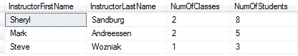

- Show the student-last-name and instructor-last-name for all cases where a student is taking a class from an instructor less than 25 years older than themselves. (15 points)

Two solutions are shown. Others are possible, although the output should match one of these two. Note that showing the date columns is optional – it helps with validation.

Solution One:

SELECT StudentLastName, StudentDateOfBirth,
InstructorLastName, InstructorDateOfBirth
FROM Enrollment AS E JOIN Class AS C
ON E.ClassID = C.ClassID
JOIN Instructor AS I ON I.InstructorID = C.InstructorID
JOIN Student AS S ON S.StudentID = E.StudentID
WHERE DATEDIFF(year, InstructorDateOfBirth, StudentDateOfBirth)
< 25;

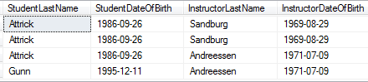

Solution Two: Change the DATEDIFF to

DATEDIFF(day, InstructorDateOfBirth, StudentDateOfBirth)
< 25 * 365;

The result includes 2 extra rows.

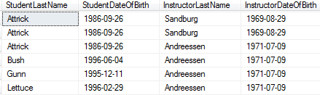

Which solution is preferable? As discussed in HW4, #40, this is dependent on interpretation. Since the classes start in Sept 2016, at that point Andreessen is 45, while Gunn is 21 and Bush and Lettuce are 20. Thus only Gunn is less than 25 years younger than Andreessen, so probably the first solution is what is wanted.

- Show each pair of student-ids taking more than one course in common. Each pair of student-ids should appear only once. The result should be ordered in increasing order by the number of common courses. (15 points)

The result should look as follows:

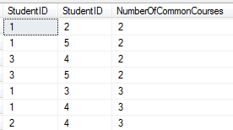

As usual, an INNER JOIN with ON yields the same solution as a CROSS JOIN with WHERE:
SELECT E1.StudentID, E2.StudentID,
COUNT(E1.ClassID) As NumberOfCommonCourses
FROM Enrollment AS E1 JOIN Enrollment AS E2
ON E1.ClassID = E2.ClassID AND E1.StudentID < E2.StudentID
GROUP BY E1.StudentID, E2.StudentID
HAVING COUNT(E1.ClassID) > 1
ORDER BY NumberOfCommonCourses, E1.StudentID, E2.StudentID;

SELECT E1.StudentID, E2.StudentID,
COUNT(E1.ClassID) As NumberOfCommonCourses
FROM Enrollment AS E1 CROSS JOIN Enrollment AS E2
WHERE E1.ClassID = E2.ClassID AND E1.StudentID < E2.StudentID
GROUP BY E1.StudentID, E2.StudentID
HAVING COUNT(E1.ClassID) > 1
ORDER BY NumberOfCommonCourses, E1.StudentID, E2.StudentID;
